2019年研究生学位英语训练试卷

Part one: Listening comprehension (20 points)

Section A: You are going to hear a report 3 times. After you hear it, you will have to fill in the 10 missing blanks, each of which consists of 1 to 3 words.

(The materials are usually VOA standard English report, or TOEFL Test Part B\C)

Section B: You are going to hear a lecture twice. After the first time, there will be a pause for 30 seconds. Then you listen to it again and answer 5 questions.

(The materials are usually similar to TOEFL Lectures)

Part two: Reading comprehension (20 points)

In this part, you will read 2 passages. After you finish reading the first passage, choose the best answer to complete the statements. (or choose the best words to complete the sentences.) For the second passage, you will answer 5 questions. Use **less than 10 words** to answer the questions.

Passage one

One in five US workers regularly attends after-work drinks with co-workers, where the most common _____1____range from bad-mouthing (说……的坏话) another worker to kissing a colleague and drinking too much, according to a study ­____2____ on Tuesday.

Most workers attend so-called happy hours to ____3_____ with colleagues, although 15 percent go to hear the latest office gossip and 13 percent go because they feel obligated, said the survey conducted for CareerBuilder. com, an online job site.

As to what happens when the after-work drinks flow, 16 percent reported bad-mouthing a colleague, 10percent shared a secret about a colleague, 8 percent kissed a colleague and 8 percent said they drank too much and acted _____4____. 5 percent said they had shared a secret about the company, and 4 percent __5______ to singing karaoke.

While 21 percent of those who attend say happy hours are good for ___6______, 85 percent said attending had not helped them get ____7_____ to someone higher up or get a better position.

An equal number of men and women said they attend happy hours with co-workers, with younger workers aged 25 to 34 most likely and workers over 55 least ___8______to attend.

Overall, 21 percent of workers attend happy hours with co-workers and, of those,____9_____a quarter go at least once a month.

The survey was ____10_____online by Harris Interactive on behalf of CareerBuilder. com among 6,987 full-time employees.

A. bond

B. acknowledged

C. nearly

D. specially

E. anywhere

F. mishaps

G. obligated

H. likely

I. conducted

J. idly

K. unprofessionally

L. networking

M. released

N. confessed

O. researched

Answer: FMAKN LEHCI

Passage 2

Educators today are more and more often heard to say that computer literacy is absolutely necessary for college students. Many even argue that each incoming freshman should have permanent access to his or her own microcomputer. What advantages do computers offer the college students?

Any student who has used a word processor will know one compelling reason to use a computer: to write papers. Although not all students feel comfortable composing on a word processor, most find revising and editing much easier on it. One can alter, insert, or delete just by pressing a few keys, thus eliminating the need to rewrite or re-type. Furthermore, since the revision process is less burdensome, students are more likely to revise as often as is necessary to end up with the best paper possible. For these reasons, many freshman English courses require the use of a word processor.

Computers are also useful in the context of language courses, where they are used to drill students in basic skills. Software programs reinforce ESL(English as a Second Language) instruction, as well as instruction in French, German, Spanish, and other languages. By using these programs on a regular basis, students can improve their proficiency in a language while proceeding at their own pace.

Science students take advantage of computers in many ways. Using computer graphic capabilities, for example, botany students can represent and analyze different plant growth patterns. Medical students can learn to interpret computerized images of internal body structures. Physics students can complete complex calculations far more quickly than they could without the use of computer.

Similarly, business and accounting students find that computer spreadsheet programs are all but indispensable to many aspects of their work, while students pursuing careers in graphic arts, marketing, and public relations find that knowledge of computer graphic is important. Education majors learn to develop grading systems using computers, while social science students use computers for analyzing and graphically displacing their research results.

It is no wonder, then, that educators support the purchase and use of microcomputers by students. A versatile toot, the computer can help students learn. And that is, after all, the reason for going to college.

Questions:

1. What does the word “literacy” (Line1, Paragraph 1) mean?

2. What is the main purpose of this passage?  
3. According to the author, what can a word processor be used to?

4. What does the writer use to develop his argument primarily?

5. What is the reason why students go to college according to the author?

Answer:  
1. The ability to use

2. Identify some of the ways that computers benefit college students

3. Revise papers

4. Examples

5. Learn something

Part three: Translation (25points)

In this part, you will translate an English passage into Chinese(10 points), and a Chinese passage into English(15 points).

English passage

This is the 22-year-old computer wizard who put a stop to the ransom ware virus that caused chaos around the world.

The British surfer, named as Marcus Hutchins, became an ‘accidental hero' after halting the global spread of the unprecedented attack.

He stopped the virus in just a few hours - by which point, it had brought chaos to the NHS (National Health System) and thousands of other victims.

It is thought he did this from a small bedroom at his parents' home, packed with video games and takeaway pizza boxes.

One of Marcus's friends said that the surfer - who had been tweeting anonymously by the name Malware Tech - was just "doing his job" when he put a halt to the spread of the virus.

Marcus realized that by registering a website domain name the virus code could be stopped.

Computer experts have warned the block on the virus may only be temporary and the hackers could easily start up a new one capable of infecting millions more computers within days.

**参考译文：**

一位22岁的电脑大神破解了在全球造成混乱的勒索病毒。

这位英国网虫名叫Marcus Hutchins，这场病毒突袭因他没有在全球蔓延。

他在几个小时内就终止了病毒——到那个时候，这种病毒已经在英国国家医疗服务体系造成了骚乱，给成千上万的受害者带来了麻烦。

据称他是在父母家属于他的那间小小的卧室里完成自己的英雄业绩的，卧室里到处是网络游戏光碟，还有披萨外卖的包装盒。

Marcus一直以Malware Tech的网名混迹在推特网上。Marcus的一个朋友说：他把终止病毒扩散的英雄壮举当成了自己的“例行公事”。

Marcus发现，只要注册一个特定网站的域名就能制止病毒程序的运行。

电脑专家警告称，对病毒的拦截可能只是暂时的，黑客可以轻而易举的创建一个新的域名，很快就能继续感染千百万的电脑。

1. Chinese passage

我国第三军医大学的研究人员日前表示，已研制出一种鉴定病人血型的低成本简易测试，准确率接近百分之百，耗时数秒。

这项新测试能够在仅仅30秒内就准确鉴定某人的血型是A、B还是O，并在约两分钟内鉴定血型的所有详细情况。

为了实现这项测试，研究人员利用了血浆蛋白和一种使用广泛的染料溴甲酚绿之间的化学反应。

每张试纸也都配备有可以识别匹配不同血型的抗体，例如他们可以在血红细胞的表面发现A型或者B型血的抗原。

当血滴在测试条上面，会有肉眼可以观察到的颜色变化，这些颜色变化会在测试纸的观察窗变化范围之内，若提交样本是血型匹配的抗原，为蓝绿色，如果没有为棕色。

研究人员已用该方法对3550份人类血样进行测试，结果准确度超99.9%，在试验中唯一失败的案例是由于血型罕见。

血浆: blood serum

溴甲酚绿: bromocresol green

**参考译文：**

Researchers from the Third Military Medical University in China said they have developed a cheap, easy test to determine a patient's blood type in a matter of seconds with nearly perfect accuracy.

The new assay is able to pinpoint whether a person is type A, B or O in just 30 seconds, and determine the blood type in full detail in about two minutes.

To create the test, the researchers took advantage of chemical reactions between blood serum proteins and a widely-available dye called bromocresol green.

Each test paper strip was also equipped with antibodies that recognized different blood type markers, such as A or B antigens, which can be found on the surface of red blood cells.

When a drop of blood was applied, the results appeared as visual color changes in the observation window of the paper strip: teal if a blood group antigen was present in a sample and brown if not.

The method was tested on 3,550 samples of human blood with results of more than 99.9% accuracy, and the only inconsistencies occurred in trials with highly uncommon blood types.

Part four: Writing (20 points)

In this part, you will write an essay on the chart, picture, or an outline given below with at least 300 words.

Write an essay explaining what the graph shows and reporting some of the information it contains. Offer some possible explanations for data, discuss the reasons why there is an increase in youth crime in industrialized countries, and suggest some solutions to the problem. Write at least 300 words.

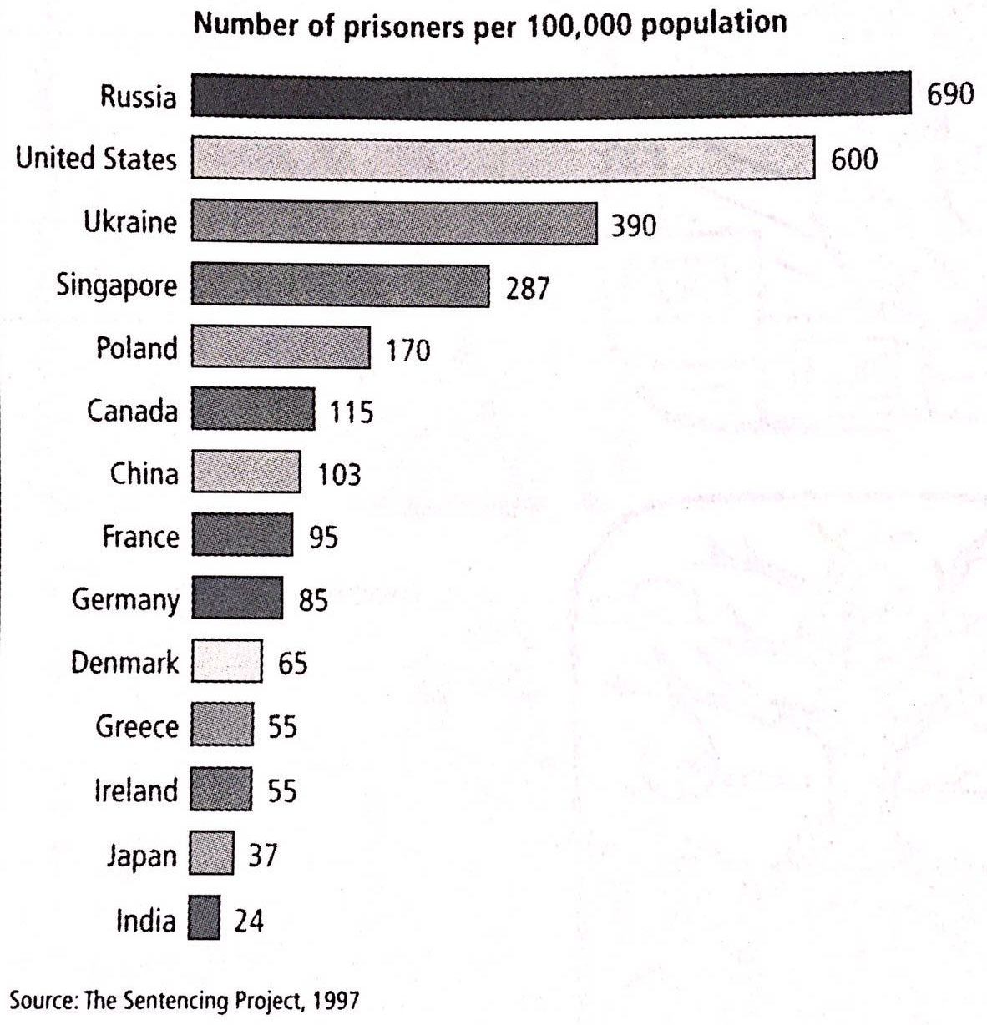

Your marks will be awarded for content relevance, content sufficiency, organization and language quality. Failure to follow the above instructions may result in a loss of marks.